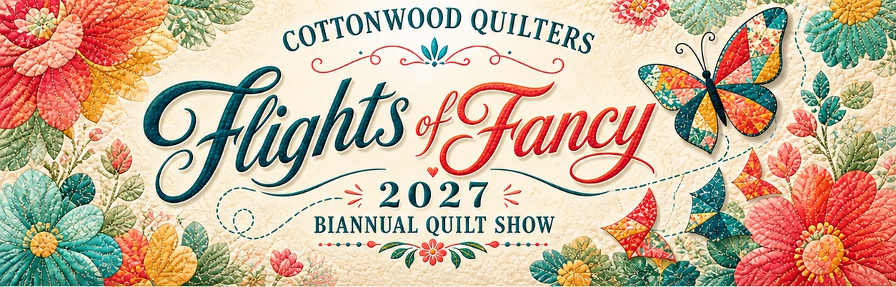
Challenge Quilt
- There must be something that represents Hawaii and Paris on the front of the quilt. That can be done through fabric, applique, embellishments or thread design.
- The perimeter must be no less than 80” and no more than 120”.
- Use any color and any quilt blocks you would like.
- A ribbon will be awarded to the winner of the challenge.
40”
20”
20”
20”

